

**STUDY OF RELATIONSHIP BETWEEN STRESS MANAGEMENT AND SELF-ESTEEM IN UNDERGRADUATE STUDENTS**

**COURSE CODE: HUM1022**

**COURSE NAME: PSYCHOLOGY IN EVERYDAY LIFE**

**FACULTY IN-CHARGE: MAYA RATHNASABAPATHY**

**REPORT SUBMITTED BY:**

**PRAGNA PULIPATI (17MIS1044)**

**K SRI HARIKA (17MIS1149)**

**ABSTRACT**

Stress is an integral part of natural fabric of life. The present study is conducted on the stress management and self-esteem of undergraduate students. In this research, we, the investigators have taken a survey of 60 students studying Under-graduate. The stress management inventory developed by Dr.Vanadana Kaushik (Udaipur) and Dr.Namrata Arora Charpe (Banasthali) is used. The self-esteem scale developed by the sociologist Morris Rosenberg was used. And it is found that there is a significant relationship between these two factors.

**INTRODUCTION**

Today, in this modern world where everything can be done just with a simple touch on our smart phones, students still undergo stress at times. While, stress is becoming the universal phenomenon, we also do have stress management tips, tools, and activities. Each and every person wants more and more for the attainment of pleasure as we can observe an increased competition in every aspect of life. Whether it be cooking, writing, singing, studying, being creative or even doing the home work, everything has become competitive and brings us stress as we compare ourselves. No doubt the competition is a must, but we also have to look for ourselves. Workplace stress occurs in these students when there is an imbalance of demands and increased pressure in the work environment. Also, these students with high stress levels tend to experience an increased risk of academic difficulties, substance abuse, and also emotional problems at times. There are ways to monitor one self and keep yourself stress free. Each student has a different experience from their college life, and work towards it. The purpose of self-esteem is to feel and imagine that people nurtured in their mind over time about their self. It is also the self-assessment of oneself. Students with high self-esteem usually feel good about themselves and better able to resolve their conflicts with their work life and also peers. Self-Esteem is a widely used concept both in popular language and also in psychology. Satisfaction of one’s need creates another need that commands the person’s attention and efforts. The theory of Maslow’s hierarchy of needs investigates the effects of self-esteem on academic performance. According to Maslow, people need to be motivated to seek personal goals that make their lives rewarding and meaningful. The scope of the present study in the fact that it aims to explore the self-esteem levels among the adolescents and find the relationship between the self-esteem and stress management.

**OBJECTIVES OF THE STUDY**

1. To obtain the stress management and coping ways in the students.
2. To obtain the level of self-esteem in the students.
3. To establish a relationship between the stress levels and the self-esteem levels in the students.

**HYPOTHESIS OF THE STUDY**

1. There is no significant relationship between the stress management levels and the self-esteem levels in the students.

**SAMPLE**

The data was collected through a survey conducted by circulating a google form questionnaire consisting the questions related to stress management and also self-esteem. This data consists data of 60 undergraduate students. The average age group was maintained to be 20. There were 25 male students and 35 female students surveyed. The age group varied from 18-21.

**TOOLS USED**

1. “ROSENBERG SELF ESTEEM SCALE (RSES)” developed by Morris Rosenberg.
2. “STRESS MANAGEMENT SCALE (SMS-KC)” developed by Dr.Vanadana Kaushik (Udaipur) and Dr.Namrata Arora Charpe (Banasthali).

**STATISTICAL TECHNIQUES USED**

To analyse the data and interpret the data, we, the investigators used the following statistical techniques.

1. Mean
2. Standard Deviation
3. z-Score
4. Correlation

**DESIGN OF THE STUDY**

The study is carried out using the descriptive survey method.

**ANALYSIS AND INTERPRETATION**

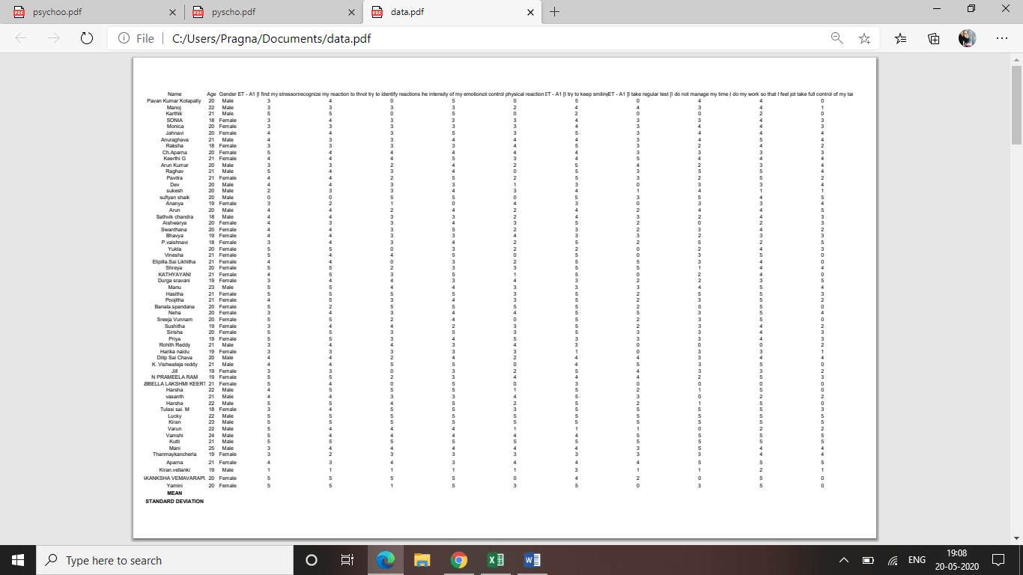

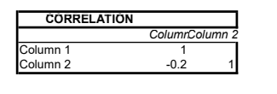

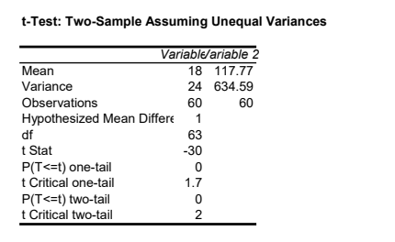

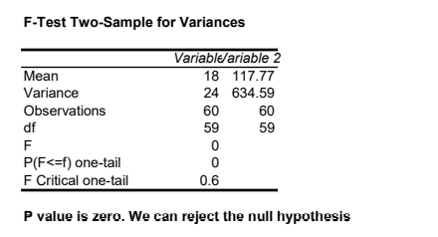

These summarize the results of the hypothesis.

* The first hypothesis contains the Correlation between both the components. The Grand Total Score of the Stress Management Test and the Grand Total Score of the Self-Esteem Test correlation was found out to be a negative. They are said to be having a negative correlation between each other which means as the Stress Score decreases the Self-Esteem score increases and the vice-versa. This is a weak negative (downhill sloping) linear relationship.
* The second hypothesis contains the t-Test between the two samples assuming they have unequal variances. As assumed, the variances, are found to be unequal with the hypothesized mean difference 1. And the degree of freedom is found to be 63. And the t Critical values is 1.7 in one-tailed and 2 in two-tailed analysis. While the P value remained to be 0.
* The third hypothesis contains the F-test for two samples for variances. Here, we use the F-statistic to compare the two variances. The degrees of freedom was found to be 59. The P values remains to be a zero. And the F and F Critical are 0 and 0.6 respectively.

**CONCLUSION**

On the basis of the discussion of the results by analysis and interpretation, it is concluded that –

There is a significant relationship between the stress factors and the self-esteem factors in the undergraduate students. Though the relationship is significant, the value of significance seems to be less as the Correlation factor represents to us the negative correlation which indicates that they are inversely proportional. But as the correlation values seems to be in lesser negatively it is only slightly chance that these both have a relation among them. This special issue also has a relationship with the student’s health and performance in the future.

**REFERENCES**

S.S.Mathur (1987). Educational Psychology, revised and enlarged eleventh edition, Vinod Pushtak Mandir, Agra.

Yazdani Mohsen, Rezaei Sara,Pahlavanzadeh Saeid (2010). The effectiveness of stress management training program on depression, anxiety and stress of the nursing students” Vol15, Issue No.4.

Y.K.Singh and R.B.Bajpai (2010). Research Methodology techniques and trends, APH Publishing Corporation, New Delhi-110002

Indu Rathee. STUDY OF STRESS MANAGEMENT. Associate Professor,T.R. College Of Education, Sonepat, Haryana

Meehl, P. E. 1956. Wanted-A good cookbook. American Psychologist. 11. 262-272.

Michels, P.J. & Layne, C. 1980. Inventory Responding Models People’s Acceptance of Feedback “Derived” From Tests and From Interviews. Journal of Personality Assessment, 48(2): 179-184.

Mundfrom, D. J., Young, S., Shaw, D. G., Thomas, A., & Moore, A. D. 2003. A common knowledge base in introductory graduate research courses. Research in the Schools, 10(2), pp. 71-78.

Forer, B.R. 1949. The Fallacy of Personal Validation: A Classroom Demonstration of Gullibility. Journal of Abnormal and Social Psychology, 44: 118-123.

Michael Shurden, Nancy Niles. Academy of Educational Leadership Journal. Lander University.

Derek Colquhoun. Researching with young people on health and environment: the politics of self-esteem and stress. Health Education Research.